Francesco Spampinato

(Rhode Island School of Design)

Video Art

The term “video art” is used to describe art made with video technologies. To not be confused with experimental cinema or art film, video art is based on a specific type of electronic image consisting of a two-dimensional composition of pixels. The main feature of video, both in technical and conceptual terms, is its instant play-back capability, not possible with film, which allows the creation of an instantaneous mirror-like replica of reality that is available to be manipulated, either live or in post-production. Video art was born in the mid 1960s and has developed in parallel to the evolution of video technologies and their increasing availability.

Video has become a major tool for artists over the past fifty years, and a quintessential postmodernist medium, which has enabled to raise critical and meta-linguistic responses to what Guy Debord (1931–1994), French writer and leader of Situationism, has called “the society of the spectacle,” referring to mainstream forms of media entertainment like television, cinema, and advertising. Video is employed to document scripted performances and improvised actions, to appropriate pre-existing moving images or to create new narratives. Artists’ videos display live or pre-recorded images in single- or multi-channel settings or as part of multimedia installations shown in exhibition spaces or in the public sphere, broadcast by TV or distributed as videotapes, CDs, DVDs and recently as digital media files.

Often cited antecedents of video art are works developed in the late 1950s by Wolf Vostell and Nam June Paik. In 1958 German artist and Fluxus co-founder Wolf Vostell (1932–1998) began to incorporate TV screens broadcasting distorted images into happenings and installations that he labeled Dé-collages and mixing them with pieces of furniture and mechanical components like auto parts. In 1959 Korean artist Nam June Paik (1932–2006), also associated with the Fluxus movement, began to distort images broadcast by television with magnets and later on with a microphone hook-up and synthesizers. Educated in music composition and influenced by the work of John Cage (1912–1992), Paik employed manipulated TV screens in performances and various types of installations.

Together with Stan Vanderbeek (1927–1984) and Steina (1940–) & Woody (1937–) Vasulka, Paik was part of a generation of artists interested in video abstraction, who also shared utopian feelings towards video as a tool to bring art to larger audiences. Paik and Vanderbeek, for example, had been involved in experimental TV programs like those produced by WGBH TV in Boston, while in 1971 the Vasulkas founded the non-profit space The Kitchen in New York, which since then has had a pivotal role in the evolution of video and performance art. The same year in New York, Electronic Arts Intermix was founded with the mission of providing a system of support, preservation, archiving and distribution of artists’ videos.

At the end of the 1960s, Dan Graham (1942–), Bruce Nauman (1941–), Frank Gillette (1941–), Ira Schneider (1939), Les Levine (1935–), and Paul Ryan (1943–2013), experimented with closed-circuit installations to explore the effects of displacement produced by video technologies as devices of control. Some of their projects were featured in TV as a Creative Medium (1969), a landmark exhibition at the Howard Wise Gallery, New York. Gillette, Schneider and Ryan, joined forces with Michael Shamberg (1945–) and others to form the video collective Raindance Corporation (1969–1974), which through its magazine Radical Software, played a pivotal role in the political Guerrilla Television movement, a network of artists and activists who produced street tapes and documentaries and was part of the wider countercultural movements that flourished around the year 1968.

The rise of Guerrilla Television as well as other coeval video practices, was a consequence of the diffusion of portable video cameras like the Sony Portapak. Artists like Peter Campus (1937–), Vito Acconci (1940–), Lynda Benglis (1941–), Joan Jonas (1936–) and Richard Serra (1939–), experimented with the effect of displacement produced by video recording private performances in their studios. American art theorist Rosalind Krauss (1941–) described these video performances as an “aesthetic of narcissism,” comparing the capacity of video to produce “instant feedback” to the psychoanalytical property of the mirror to cast an objectified image of ourselves.

As in the 1960s and 1970s television and advertising became more pervasive in society, artists began to use video to comment on the power of the mass media to create potentially damaging, distorting stereotypes with which the viewer might identify. Martha Rosler (1943–) and Dara Birnbaum (1946–) commented on the commodified role of women in the mainstream media, creating parodies of, or appropriating, found footage from popular TV shows. Other artists who used video in the 1970s and 1980s to critique TV as a system of representation are: Gretchen Bender (1951–2004), Bruce (1949–) and Norman (1946–2014) Yonemoto, Antoni Muntadas (1942–) and Stan Douglas (1960).

Between the end of the 1970s and early 1980s, a group of California-based artists began to document their performances with video. Mike Kelley (1954–2012), Paul McCarthy (1945–) and Tony Oursler (1957–), later associated to the idea of “abjection” theorized by French psychoanalyst Julia Kristeva, staged masquerades where they investigated various phobias and perversions. Sometimes, their video performances were built around satirical personas, inspired by TV comedians like Ernie Kovacs (1919–1962) and Andy Kaufmann (1949–1984), and were pervaded by an atmosphere of wickedness and abuse.

Since the end of the 1980s, video art has had a major role in contemporary art. More advanced technologies and software for the production and exhibition of videos brought artists to experiment with different forms of narration, borrowing elements from cinema, literature and philosophy. Among these artists are Matthew Barney (1967–), Eija-Liisa Athila (1959–), Tacita Dean (1965–) and Mark Lewis (1958). Others like Bill Viola (1951–), Gary Hill (1951–), Doug Aitken (1968–), Douglas Gordon (1966–), and Christian Marclay (1955–), directed their attention towards the effects of the scale and time of moving images on viewers, exploring the context of the “dark room” or displaying videos outdoors on large screens, turning them into part of the urban landscape.

References and further reading

Bellour, R. (2013), Between-the-Images, Zurich: JRP Ringier

Comer, S., Eamon, C., Newman, M. & Paul, C. (eds.) (2009), Film and Video Art, London: Tate Publishing

Hall, D. & Fifer, S. J. (eds.) (1990), Illuminating Video: An Essential Guide to Video Art, New York: Aperture Foundation

Hanhardt, J. G. (ed.) (1986), Video Culture: A Critical Investigation, Rochester: Visual Studies Workshop Press

Krauss, R. (1976), Video: The Aesthetics of Narcissism, October, Vol. 1: pp. 50-64

Rush, M. (2003), Video Art, London: Thames & Hudson

Images suggested

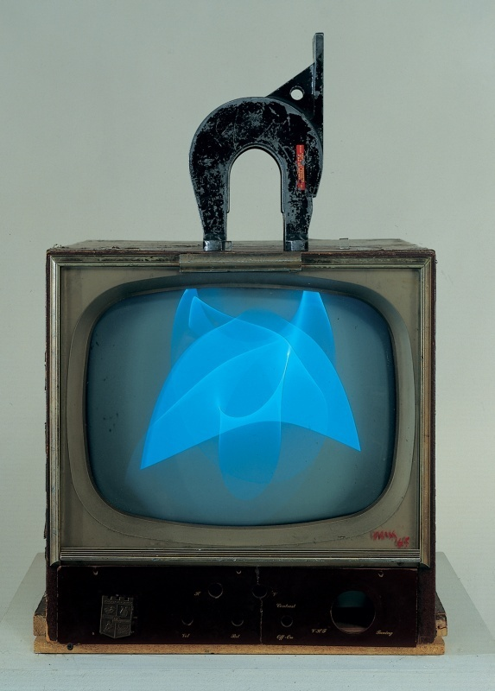

Author: Nam June Paik
Title: Magnet TV
Medium: Video installation
Year: 1965
Source: Whitney Museum of American Art, New York
http://whitney.org/Collection/NamJunePaik/8660aB/

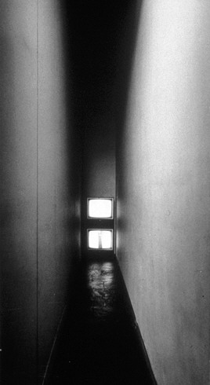

Author: Bruce Nauman
Title: Live-Taped Video Corridor
Medium: Video installation
Year: 1970
Source: Guggenheim Museum, New York
http://www.guggenheim.org/new-york/collections/collection-online/artwork/3153

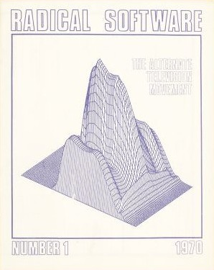

Author: Raindance Corporation
Title: Radical Software, Issue 1
Medium: Magazine cover
Year: 1970
Source: radicalsoftware.org
http://www.radicalsoftware.org/e/volume1nr1.html

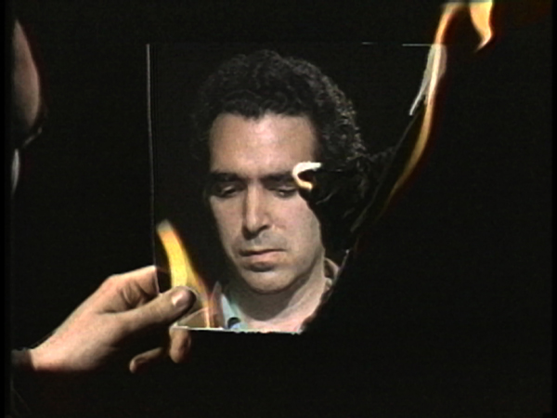

Author: Peter Campus
Title: Three Transitions
Medium: Video
Year: 1973
Source: Electronic Arts Intermix, New York
http://eai.org/title.htm?id=3127

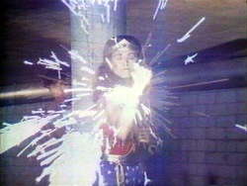

Author: Dara Birnbaum
Title: Technology/Transformation: Wonder Woman
Medium: Video
Year: 1978-1979
Source: Electronic Arts Intermix, New York
http://www.eai.org/title.htm?id=1673

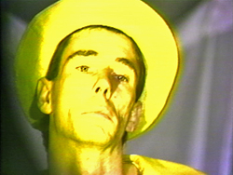

Author: Mike Kelley
Title: Banana Man
Medium: Video
Year: 1983
Source: Electronic Arts Intermix, New York
http://www.eai.org/title.htm?id=2099

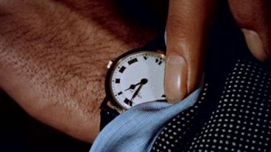

Author: Christian Marclay
Title: The Clock
Medium: Video
Year: 2010
Source: MoMA, New York; Tate, London; Centre Pompidou, Paris.

